Chapter 8, Solution 13.

Let R||60 = R_{o}. For a series RLC circuit,

ω_{o} = 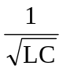 = 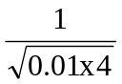 = 5

For critical damping, ω_{o} = α = R_{o}/(2L) = 5

or R_{o} = 10L = 40 = 60R/(60 + R)

which leads to R = 120 ohms

